BERESKIN & PARR LLP/S.E.N.C.R.L., S.R.L.
SCOTIA PLAZA
40 KING STREET WEST
40th FLOOR
TORONTO
ONTARIO M5H 3Y2
Attention: Sharyn Costin

RE: | Trade-mark: | SNOWLINK Design
 | Applicant: | Triangle Tyre Co., Ltd.
9 juil/Jul 2013
Votre référence Your File
10628-
Notre référence Our File
1604144

This examiner's report concerns the above identified application. To avoid abandonment proceedings, a proper response must be received by this office by January 9, 2014. All correspondence respecting this application must indicate the file number.
A certified copy of the China registration to issue from application No. 11792223 dated November 23, 2012 is required in compliance with the provisions of subsection 31(1) of the Trade-marks Act together with the prescribed fee of $50.00.
Upon satisfactory compliance with the above-mentioned requirement, further office action will be undertaken.
If the applicant has any specific questions in respect of this Office action, please contact the assigned examiner. Please note that for general inquiries, including assistance with filing of the revised application, queries about the status of an application or receipt of correspondence, you may contact our Client Service Centre toll free at 1-866-997-1936.

Yours truly,

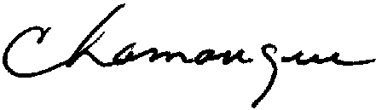
Claire Lamanque
Examination Section
819-635-4839
fax: 819-953-2476

