19 sept/Sep 2019
Votre référence Your File
3010679
Notre référence Our File
1889483
Numéro EI IR Number
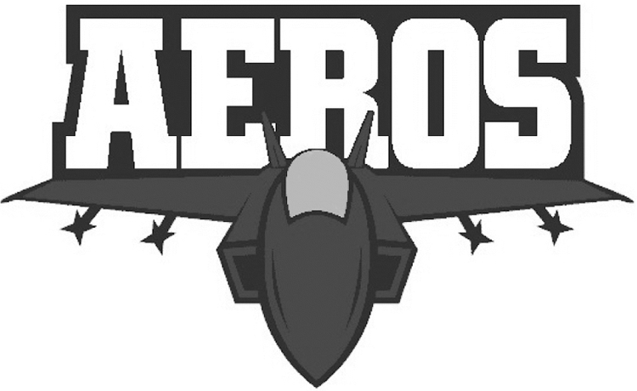
Axel Axmann
6336 13 Ave
Edson
ALBERTA T7E 1S2
RE: | Trademark: | Jet Plane with the word 'Aeros' in red, white, blue & silver
 | Applicant: | Axel Axmann

This examiner's report concerns the above identified application. To avoid abandonment proceedings, a proper response must be received by this office by March 19, 2020. All correspondence respecting this application must indicate the file number.
Thank you for your correspondence of September 13, 2019.
The applicant’s revised application has been reviewed. However, the applicant has changed their trademark image to one of black and white. Please note that if the application contains a colour claim (as it does now), the image provided must also be in colour and correspond to the colour claim. If the image of the mark is in black and white, there must be no colour claim. In the present case, the applicant has provided a colour claim and an image in black and white. This inconsistency is in violation of paragraph 30(d) of the Trademarks Regulations. The applicant is required to submit a colour image of their trademark that corresponds to the colour claim or delete the colour claim and have a black and white image.
A revised application is required.
Upon satisfactory compliance with the above-mentioned requirement(s), further office action will be undertaken.
If the applicant has any specific questions in respect of this Office action, please contact the assigned examiner. Please note that for general inquiries, including assistance with filing of the revised application, queries about the status of an application or receipt of correspondence, you may contact our Client Service Centre toll free at 1-866-997-1936.

Yours truly,

Jordan Ramsay
Examination Section
819-635-7938
fax: 819-953-2476

