9 août/Aug 2019
Votre référence Your File
3010679
Notre référence Our File
1889483
Numéro EI IR Number
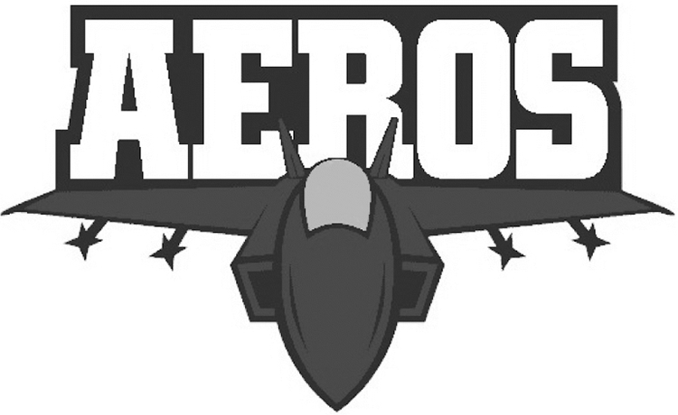
Axel Axmann
6336 13 Ave
Edson
ALBERTA T7E 1S2
RE: | Trademark: | Jet Plane with the word 'Aeros' in red, white, blue & silver
 | Applicant: | Axel Axmann

This examiner's report concerns the above identified application. To avoid abandonment proceedings, a proper response must be received by this office by February 9, 2020. All correspondence respecting this application must indicate the file number.
In compliance with paragraph 30(e) of the Trademarks Regulations, if the trademark does not consist exclusively of a single colour or a combination of colours without delineated contours, any visual representation provided must be in black and white. The applicant is required to provide a representation of the trademark that complies with the Regulations.
Pursuant to subsection 30(3) of the Trademarks Act, the application must group the goods and services according to the classes of the Nice Classification. The bolded goods and services below appear to be improperly classed. Please see the recommended class in brackets next to each entry.
(2) Promotional items, namely coffee cups, water bottles, fridge magnets [class 9]
(3) Promotional articles of clothing and headgear, namely: jerseys, pants, track suits, hoodies, sweatshirts, t-shirts, jackets, helmets [class 9 if for safety, class 28 if a toy or novelty] and hats
(1) Provision of a website in the field of hockey instruction and hockey goaltending instruction [see comments below] providing databases featuring general and local news and information of interest to hockey fans [class 41], association services namely, promoting the interests of hockey clubs, hockey players, hockey coaches, hockey team owners, hockey fans, and the game of hockey; association services, namely developing and implementing social and charitable programs on behalf of, inspired or promoted by, or through the participation of, hockey players and other athletes;
(2) Organizing and conducting hockey tournaments and training clinics; providing entertainment and amusement through the medium of hockey games; the organization and administration of a hockey club; promoting the sport of hockey through the organization of a hockey team, providing of entertainment and amusement through the medium of hockey games, the organization and administration of ice hockey competitions [class 35]; planning sporting events namely hockey events and hockey instruction; promoting and encouraging the increased recreational activity and physical fitness amongst Canadians through participation in recreational hockey [class 35]; providing educational instruction regarding skating, hockey skills, goaltending and timekeeping and officiating of hockey games; conducting workshops and seminars in hockey instruction.
The service of “providing a website” is considered to be too vague for the purposes of Nice classification since the primary branch of activity is unclear. For example, services such as “providing a website about hockey instruction” are not considered to be specific enough to determine an appropriate Nice class since the services can refer to:
- “providing access to a website about hockey instruction” in class 38,
- “hosting a website about hockey instruction” in class 42, or
- “providing information about hockey instruction via a website” in class 41. **
A revised application is required.
Upon satisfactory compliance with the above-mentioned requirement(s), further office action will be undertaken.
If the applicant has any specific questions in respect of this Office action, please contact the assigned examiner. Please note that for general inquiries, including assistance with filing of the revised application, queries about the status of an application or receipt of correspondence, you may contact our Client Service Centre toll free at 1-866-997-1936.

Yours truly,

Jordan Ramsay
Examination Section
819-635-7938
fax: 819-953-2476

